Colour Scheme Research  http://www.colorschemedesigner.com/  (Print Screen 4 Colour Options below) | Comment (why is this colour suitable)  Target Audience, Theme, Colour Scheme.
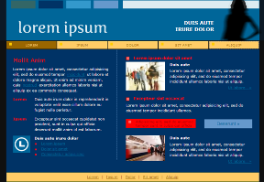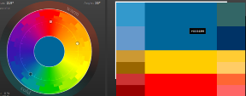 | This dark coloured red-blue colour scheme suits my theme because the information that my site contains information about space and the blue resembles the sky. I chose a triad colour to manifest ‘Earth Water and Fire’ – Science
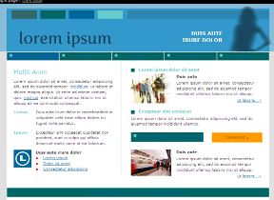  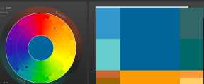 | The blue and orange complementary colours would be suitable for my website to give my theme a complement to its readers. With this page sample, we can see that the use of the white space makes the website stand out without eliminating the theme and conveying it successfully to the target audience
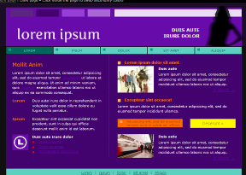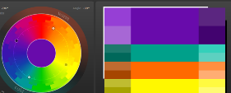 | A dark coloured violet with orange and yellow to emphasise calmness and balance because Science articles are not supposed to be stressful to read through
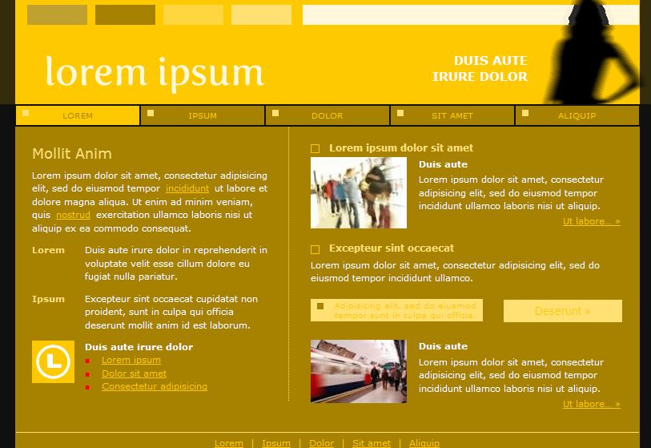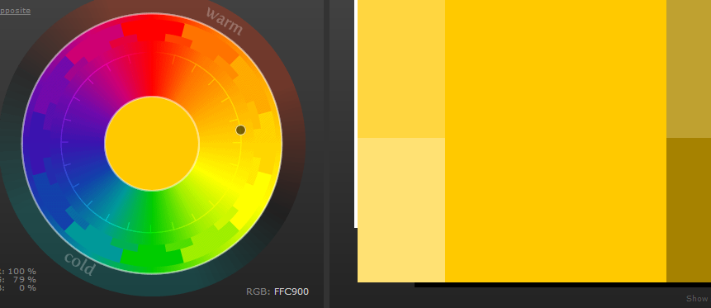 | I am planning to use a monochrome yellow to go with solar energy – a symbol of continuity because science goes on. This colour will be suitable for my website if I am able to manage it correctly
Colour Evaluation (choose 1 final colour scheme)
Final Colour Scheme = Red-Blue-Yellow in light colour (1st C.S.)
This dark coloured red-blue colour scheme suits my theme because the information that my site contains information about space and the blue resembles the sky. I chose a triad colour to manifest ‘Earth Water and Fire’ – Science. My colour scheme will also suit the fonts that I’m planning to use because they are modern, my theme is modern and so my colour scheme should be modern

